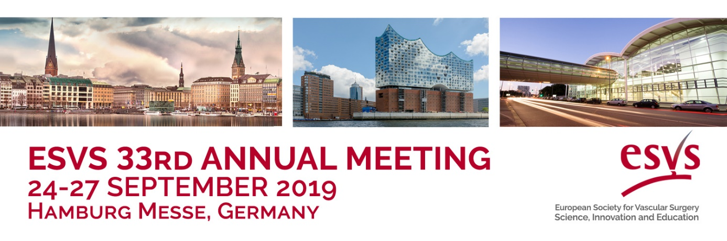
The ESVS Annual Meeting brings the vascular community together to give vascular specialists a platform to learn, share, socialise and grow.
Join us in Hamburg on 24-27 September 2019 to access the latest developments in Vascular Surgery!
Check out some of the exciting components of this year’s event:

- 2 Guidelines will be presented for the first time ever:
ALI Guidelines – Chaired by Prof. M. Björck and Prof. J. Earnshaw
Vascular & Endovascular Graft Infections - Chaired by Prof. N. Chakfe
and Dr. H. Diener
- Dr. Jack L. Cronenwett will deliver a lecture on Evidence in Vascular Surgery and Dr. Krassi Ivancev will present his lecture on Innovation in Vascular Care
- This years’ all-star cast of speakers will include, among others: Dr. S. Anand; Prof. D. Böckler; Prof. R. Hinchliffe; Dr. T. Mastracci; Prof. E. Verhoeven;
Prof. A. Wanhainen; Dr. W. Yakes
- 2 day ESVS Academy Programme comprising of more than 60 hands-on workshops and interactive case discussions
Visit the ESVS Annual Meeting website for more information and timely updates on the event.
We look forward to welcoming you in Hamburg this autumn!

